the SU Internal Management System

A guide and instructions for how to navigate and set up the system.

By: Jason Wang & G11 HR Group

**Document Version Log:**

|  |  |
| --- | --- |
| Version: | Changes: |
| 1.0.0 | Initial description of all of the sections except regarding events. |
| 1.0.1 | Added description of events functionality. |
| 1.0.2 | Updated Formatting |
| 2.0.0 | Added information about v2.0.0 and v2.0.1 as well as technical details about the software. |

The software and this document are available at the GitHub repo: <https://github.com/chungchunwang/Student-Union-System>. Refer there for the latest version.

Please report any errors or inconsistencies in this document [wangchongjun@hanvos-kent.com](mailto:wangchongjun@hanvos-kent.com)

Table of Contents

About 4

System Guide 5

Setup 6

Home 7

Admin Dashboard 8

Review Project Proposals 9

Review Questions 10

User Reference 11

Groups 12

Create Awards 13

Create Tasks 14

My Groups 15

Add Task 16

My Tasks 17

Completed Tasks 17

Profile 18

Awards 19

Leaderboard 20

My Project Proposals 21

Report 23

My Events 24

Create New Event (Create new button) 25

Review absences (Review absense button) 26

edit (Edit button) 26

View (View Button) 27

Edit Required Attendance (Edit Required Attendance Button) 27

Log Attendance (Log Attendance Button) 28

End Attendance 28

Events 29

Event Page (View Button) 29

Questions 31

Files 32

Bug Reports 32

Documents 33

Software Version Log 34

Known bugs and issues 38

About the software & its design 38

Why low code? 38

Why MYSQL? 38

How is it hosted? 38

System Setup 38

# About

This document covers the SU Internal Management System, a system used to manage tasks, events, questions, project proposals, users and other vital data in everyday student union management. Besides data management, it also facilitates the concept of “points”, allowing users to earn credit for taking part in tasks, events, and project proposals.

For those looking for instructions on how to use the system, you can refer to the system guide section.

For those looking to understand the software, you can refer to the about the software section.

For those looking for instructions on how to setup the system, you can refer to the setup guide section.

# System Guide

This is the one stop shop for tasks, events, and much more! Read this short guide to be able to use it effectively.

Before we dive into an explanation of each page, lets understand the different account types within the system. The SU Dashboard is a closed internal system. This means that it is meant for only members. Outsiders will not be able to see its content.

For members, there are 3 different account types, in descending order of permission level:

1. Admin
2. Power
3. Basic

Per design, Basic accounts should be assigned to regular members, Power accounts should be assigned to group leaders and subleaders, and Admin accounts should be given to SU leaders.

Some features are only available for certain members. In the following documentation such features (or entire sections!) will be marked with For Access level: _________ to indicate this.

Now, let’s take a look at what is in each page.

## Setup

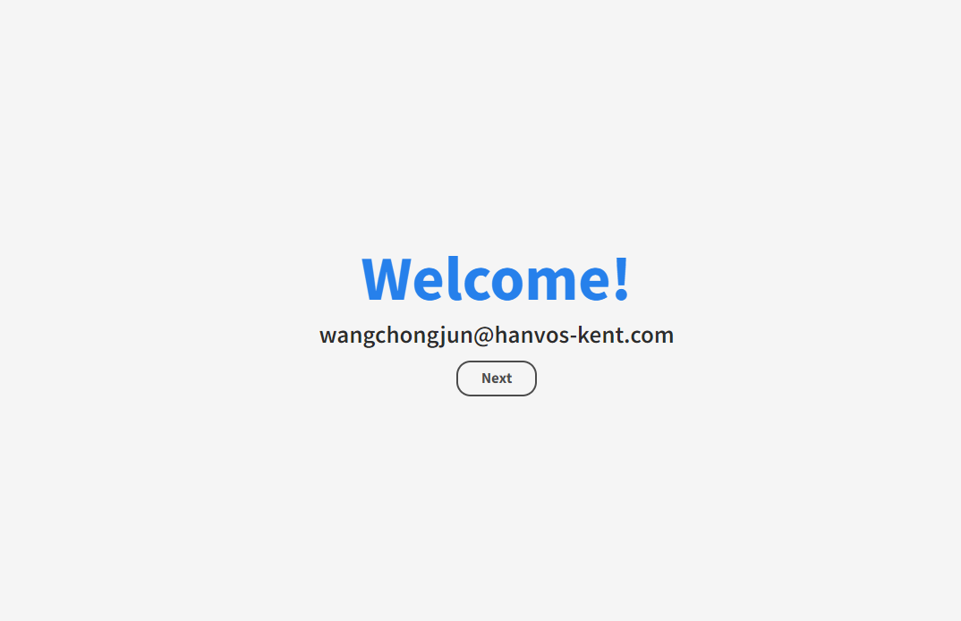

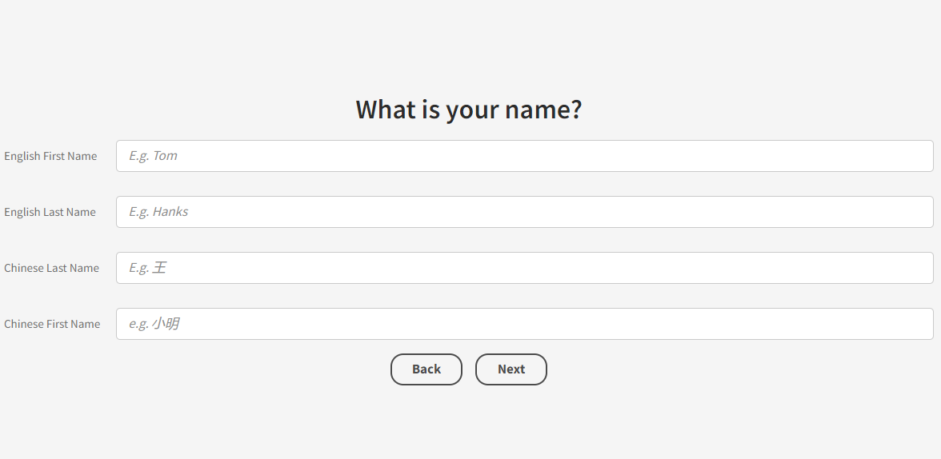

When you first login into the system, you will be met with a setup page, where you will have to fill in details about yourself (name, class, etc.). Enter this information accurately and honestly as they will affect how you are represented within the system.

## Home

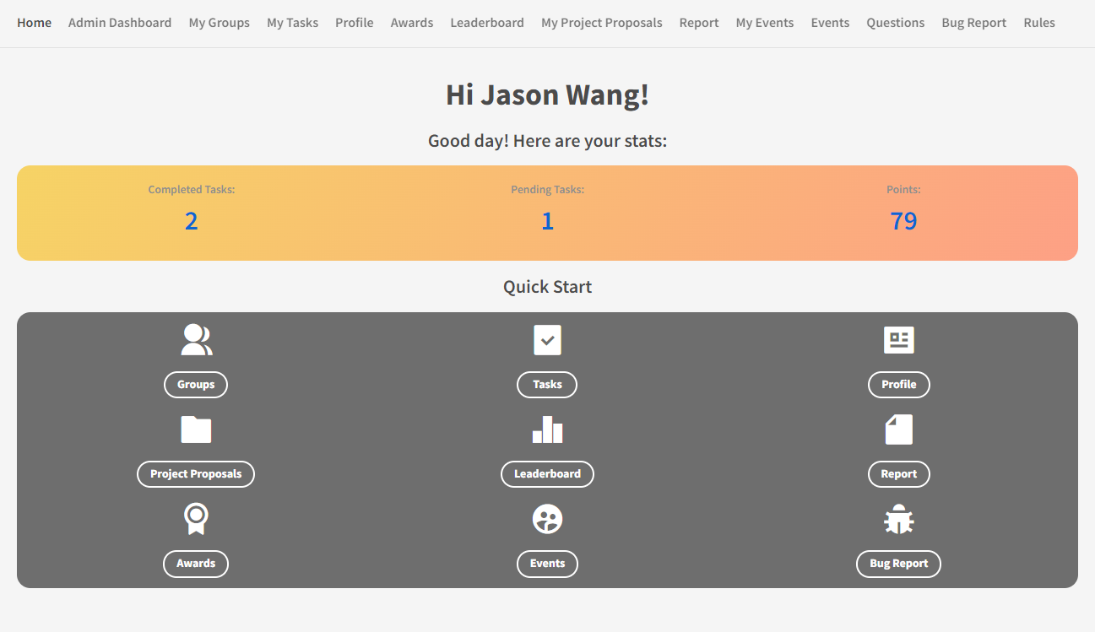

This is the page you see when you login. Here, you will see a quick overview of your statistics, as well as a couple of quick access buttons. All of these though, are accessible from the top bar as well!

## Admin Dashboard

For Access level: admin only

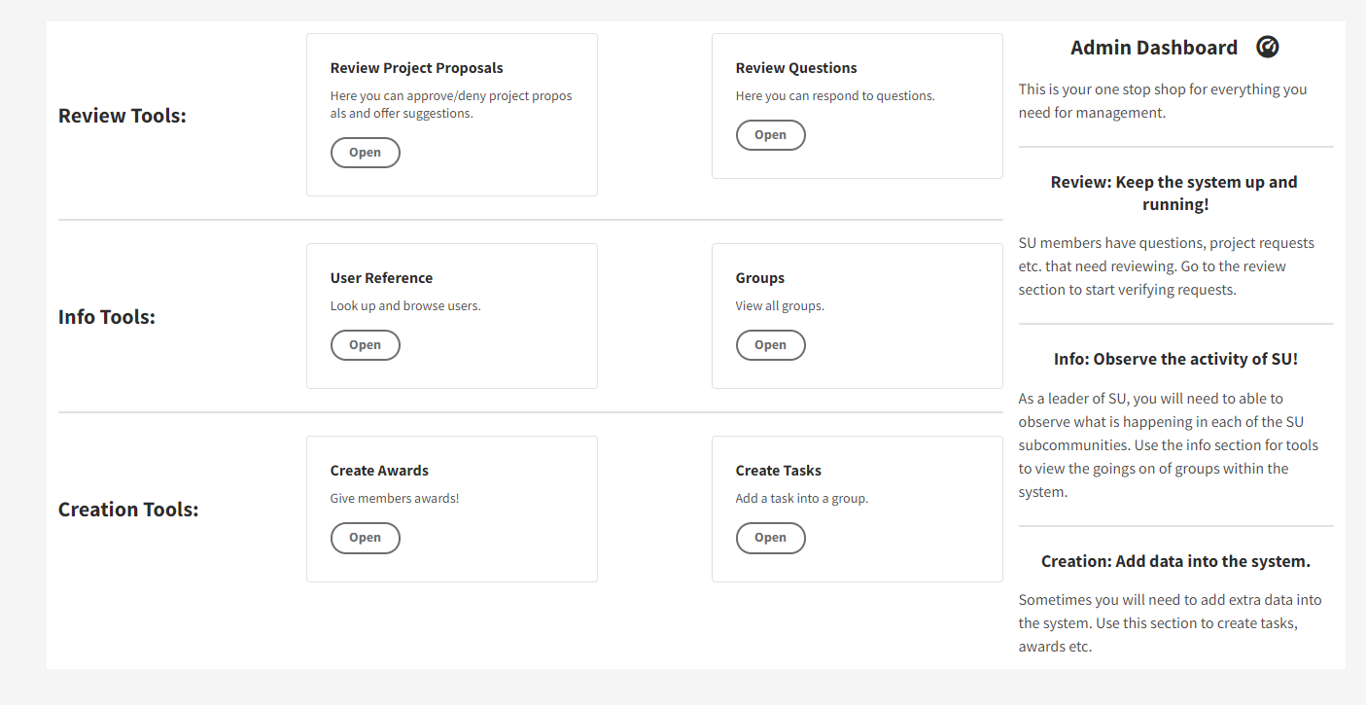

Here you will find a variety of tools to manage the system. Be careful though[1], as you are free to change almost anything. These are a number of subpages for each of the tools.

### Review Project Proposals

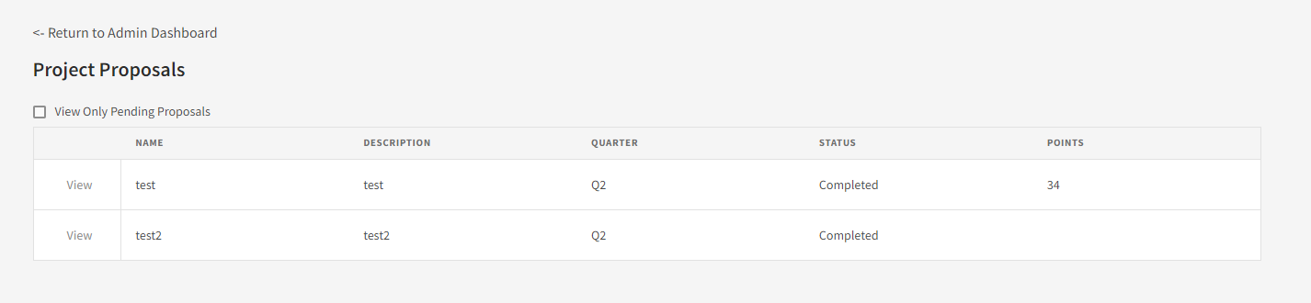

Here, administrators can review project proposals submitted by SU members. Click “View” to approve/disapprove and to make changes.

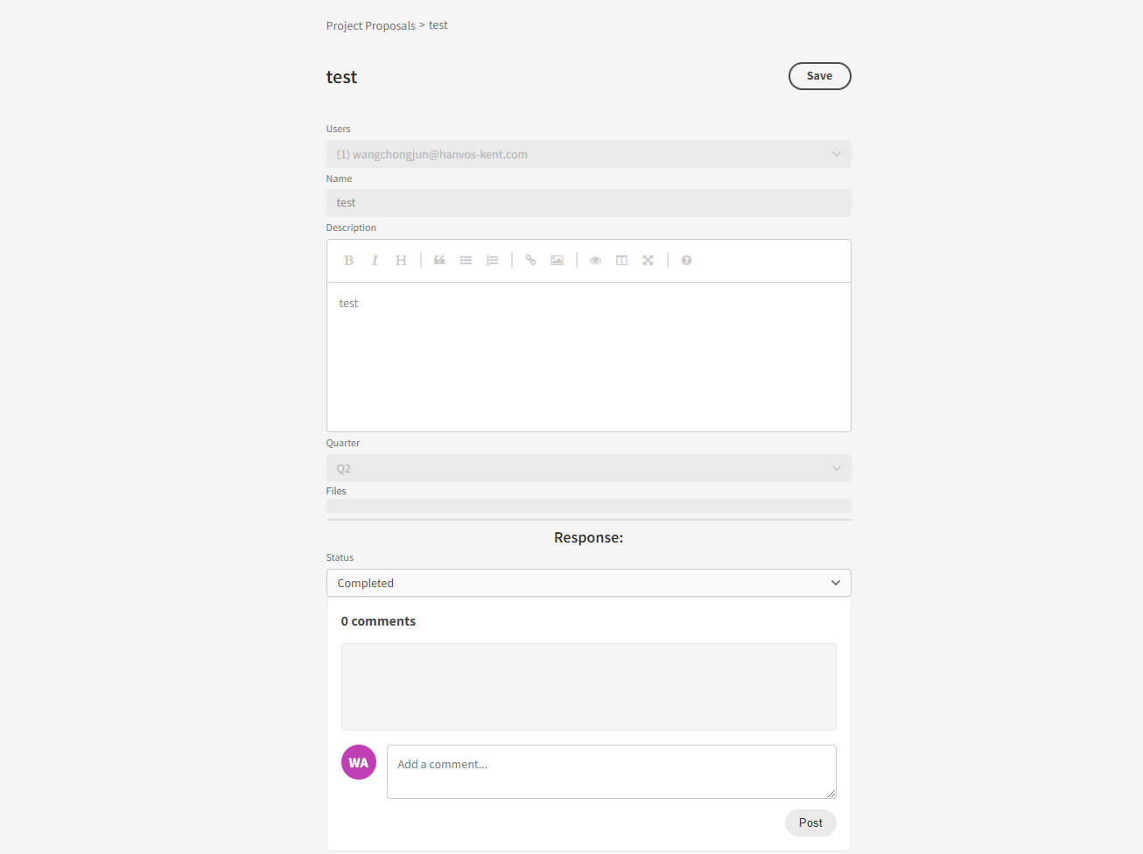

Here, submit the status of the proposal (whether you approve or deny it), and add a comment if you like.

### Review Questions

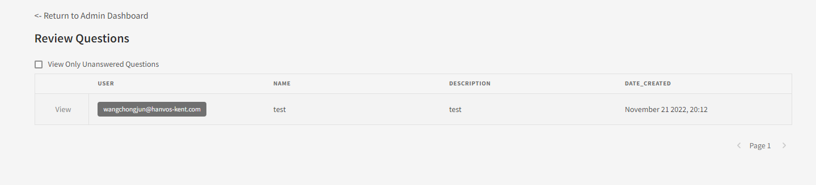

All members are able to submit questions. On this page, you can respond to them. To do so, press view on a question.

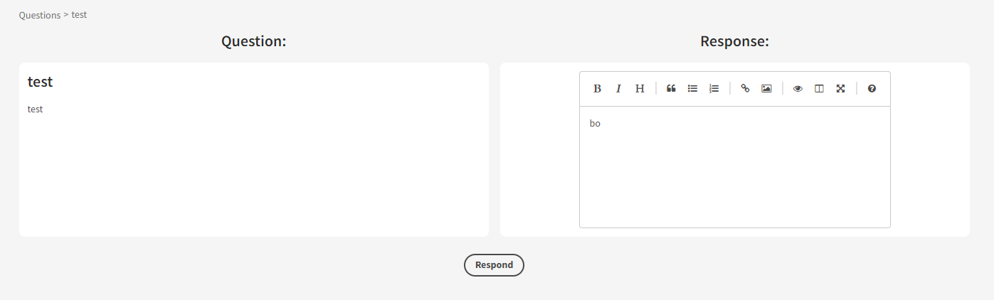

Respond the question on this page, and then press Respond.

### User Reference

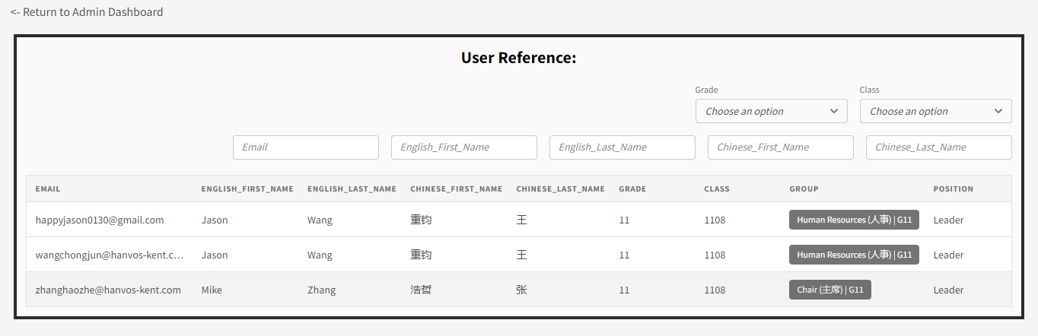

Use this page to search though all users in the system. You can filter by a variety of variables.

### Groups

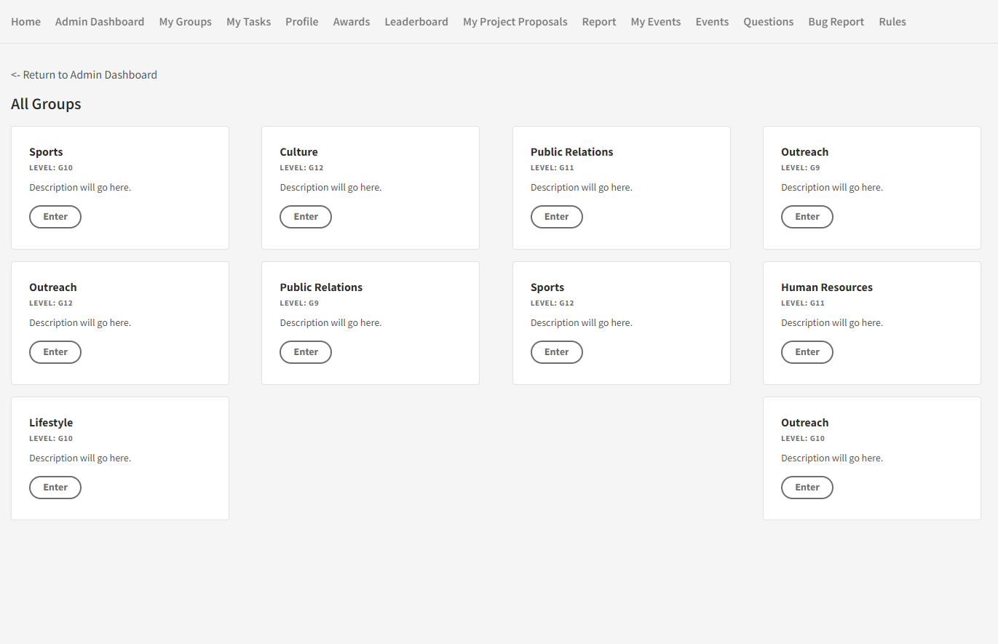

This is a powerful admin tool that allows you to access the group page of any of the groups in the system. You can make changes just as if you were a power user within the group. View the My Group section for more information.

### Create Awards

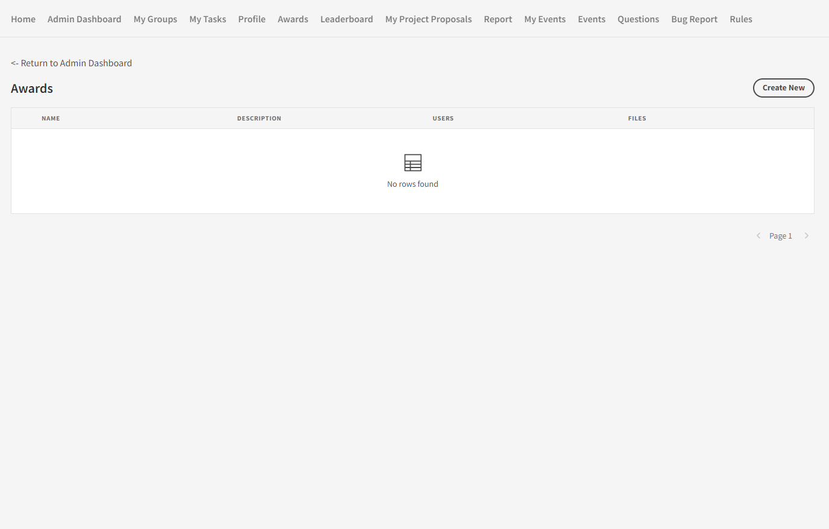

On this page, you can grant awards to users. Press Create New to generate a new award.

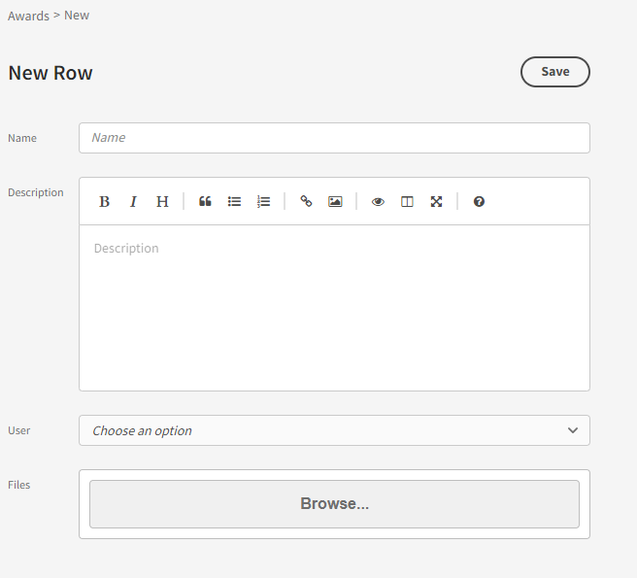

Here, fill in the relevant information and press Save to create the award. If you have a digital document for the award, add it in the files section. To see what an award in the system looks like, view the Awards section.

### Create Tasks

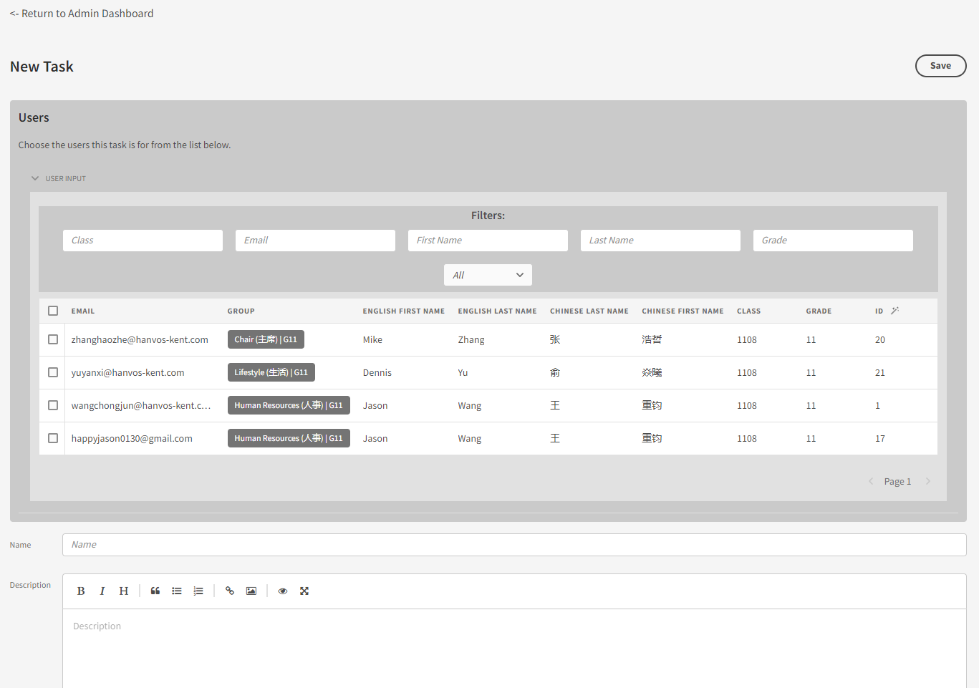

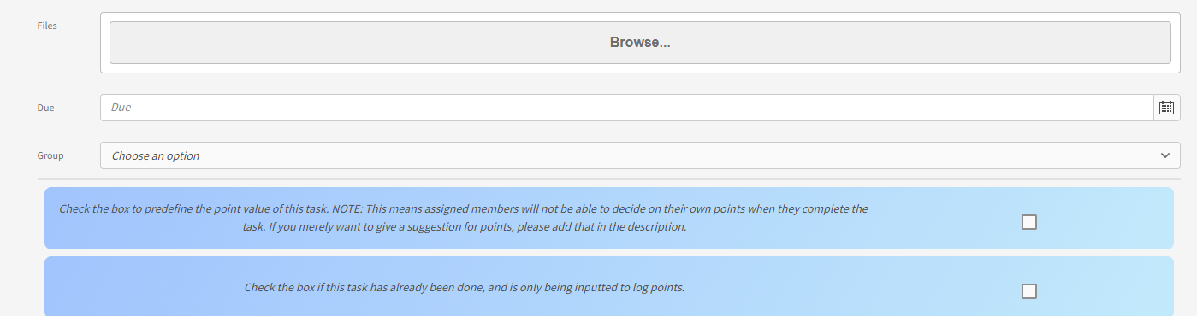

On this page, you can arbitrarily create tasks and drop them into any group. It is recommended, however, that you instead create tasks using the Groups feature of the Admin Dashboard. View the Add Task section to see what each of the fields do.

## My Groups

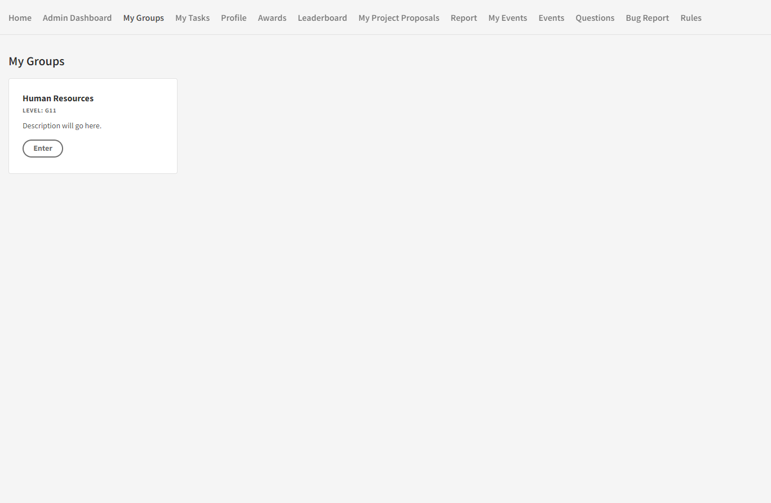

Here you will be able to access the group you are a part of. Click on the group to enter.

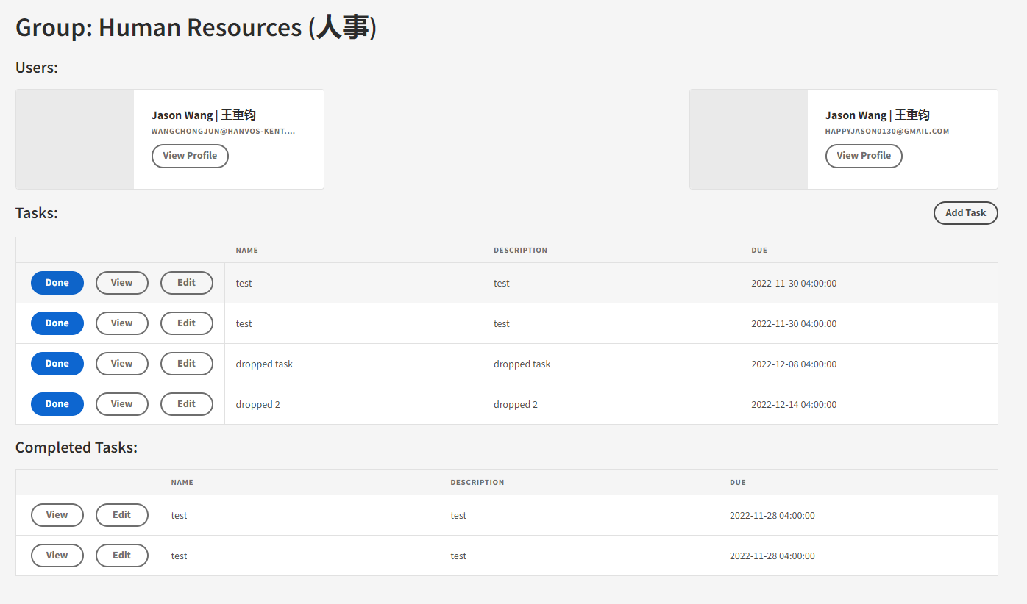

On this page, you will see the members of your group as well as completed and pending tasks.

### Add Task

For Access level: Power and Above

Click the Add Tasks button to create a new task for group members.

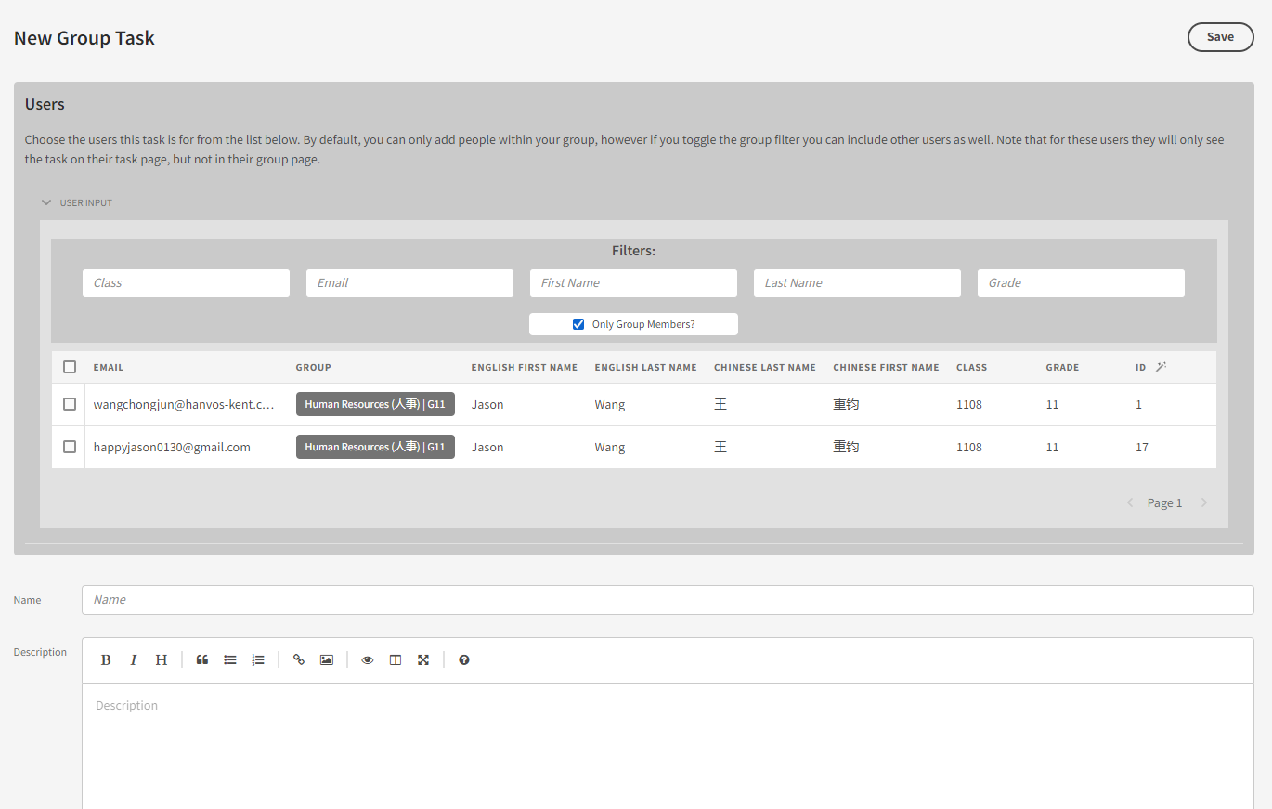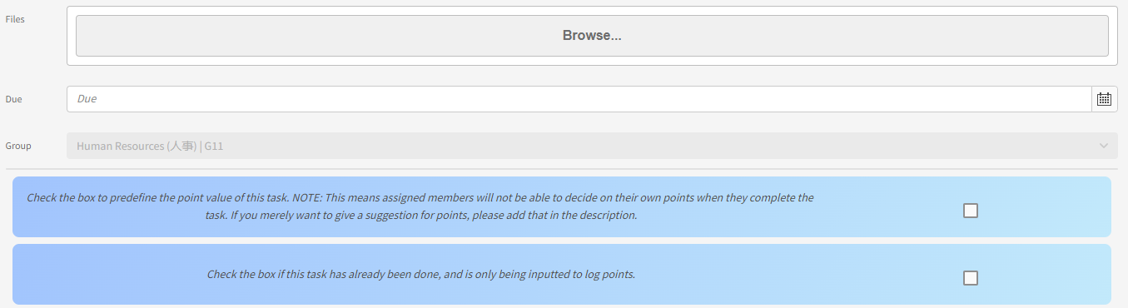

**Form Field Description:**

|  |  |
| --- | --- |
| Field | Description |
| Name | The name of the task. |
| description | The description of the task. Can be written in markdown. |
| file | Files you wish to attach to the task. |
| Due | The due date of the task. |
| Group | What group the task is in (You cannot change this). |
| Predefined Points (blue Checkbox 1) | Used to add preset points for a task. This will prevent users from manually inputting points for themselves when they complete the task. |
| already completed (blue checkbox 2) | Select if the task is already completed, and is only being used to log the task for points and future reference. A field will appear for you to input points in. |

## My Tasks

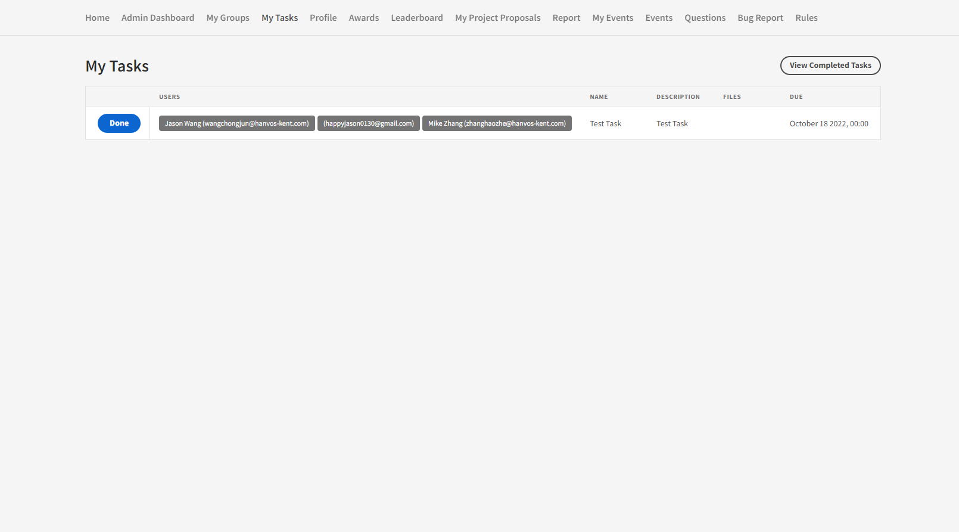

This is a faster way to access the tasks from your group. Here you can see all list of all these tasks you need to do.

### Completed Tasks

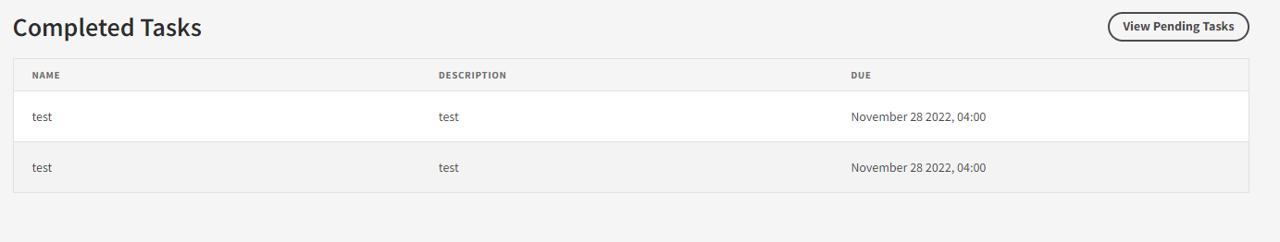

Click View Completed Tasks to see all of the tasks you have completed.

## Profile

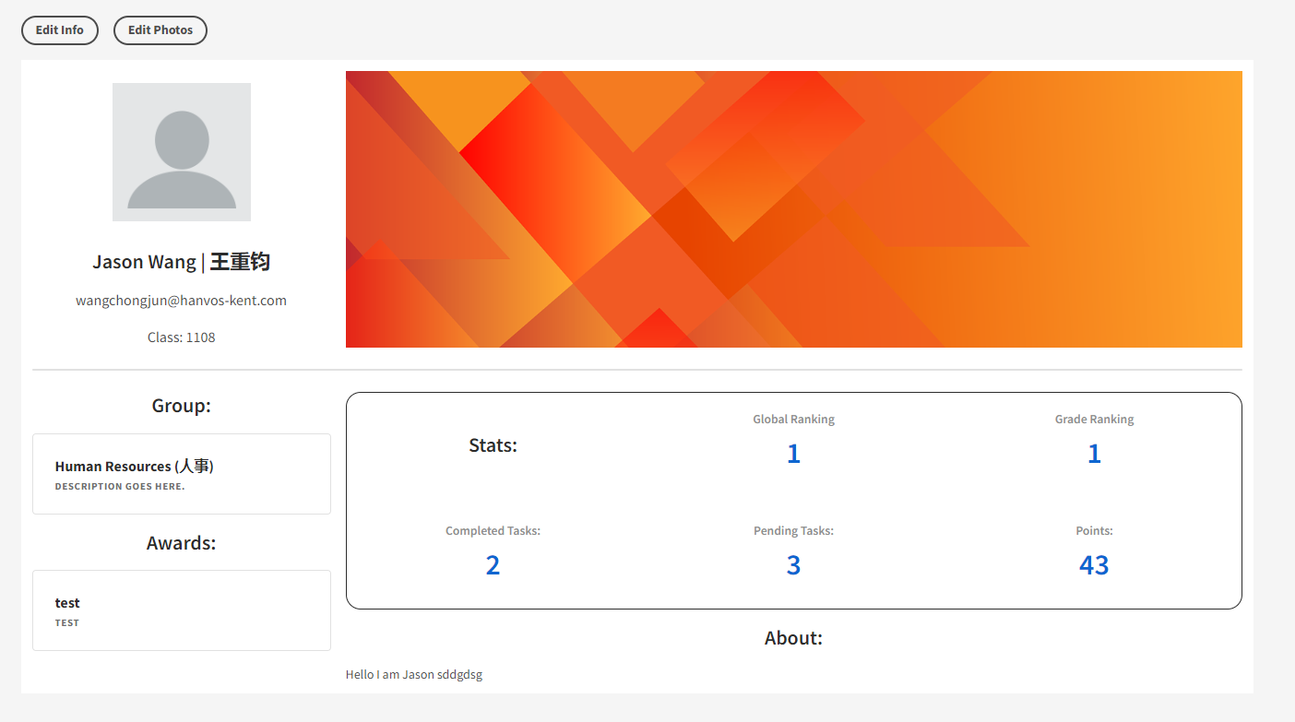

Here users can create custom profile pages that are viewable to all members of the organization. Click Edit Info to change your account information and click edit photo to change your profile and banner image.

## Awards

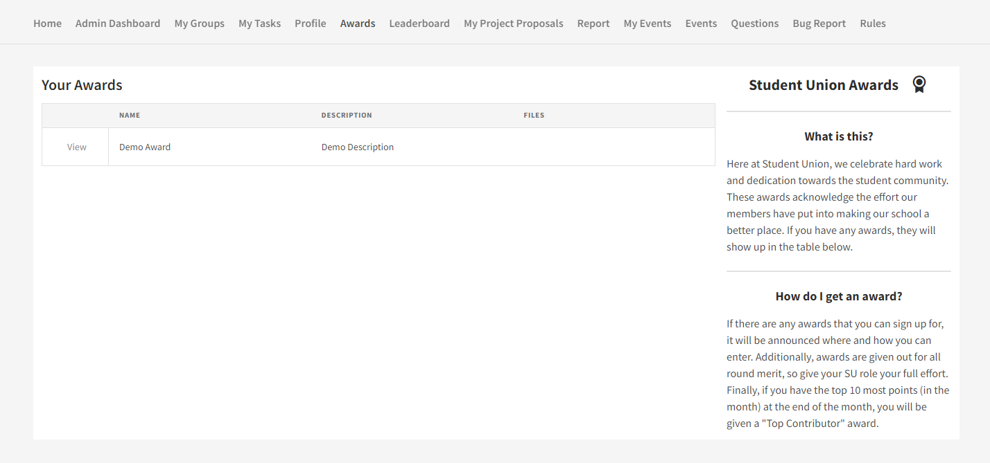

Here users can see award given to oneself. You can view the award and download its provided certificate document (if provided).

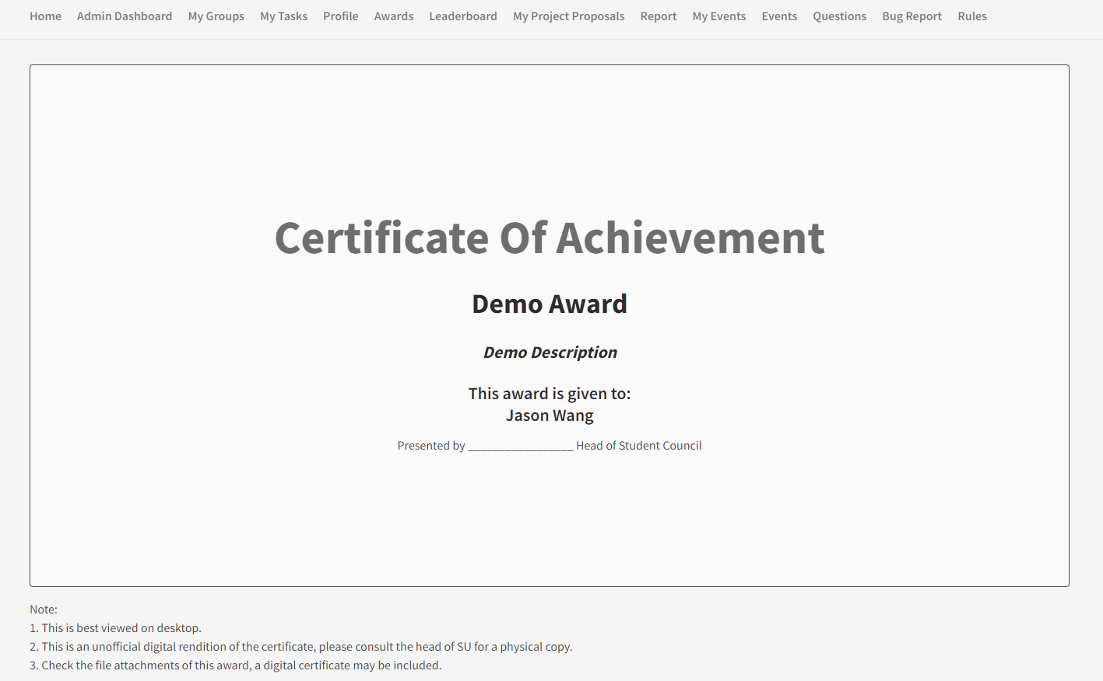

This is the page you see when you open an award.

## Leaderboard

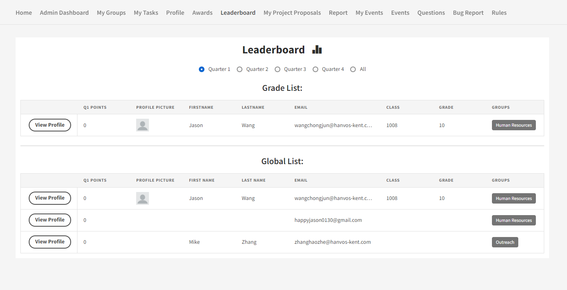

Here you can see global rankings of members of the organization based on points. You can filter by quarter or all.

## My Project Proposals

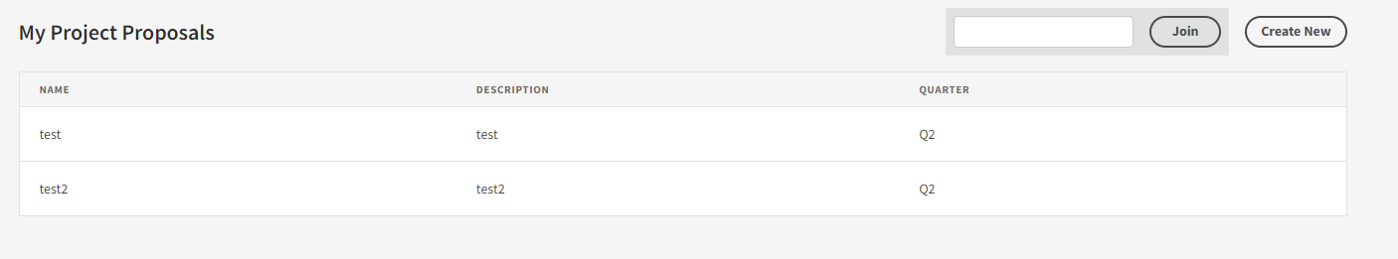

Here you can manage and create project proposals. Click on Create New to do so.

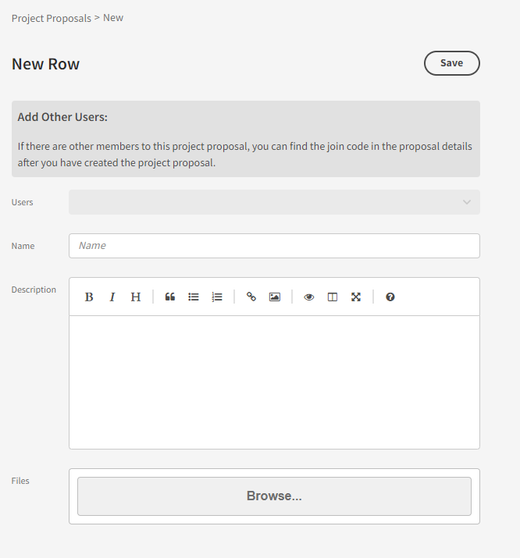

Fill in the relevant information and then Save.

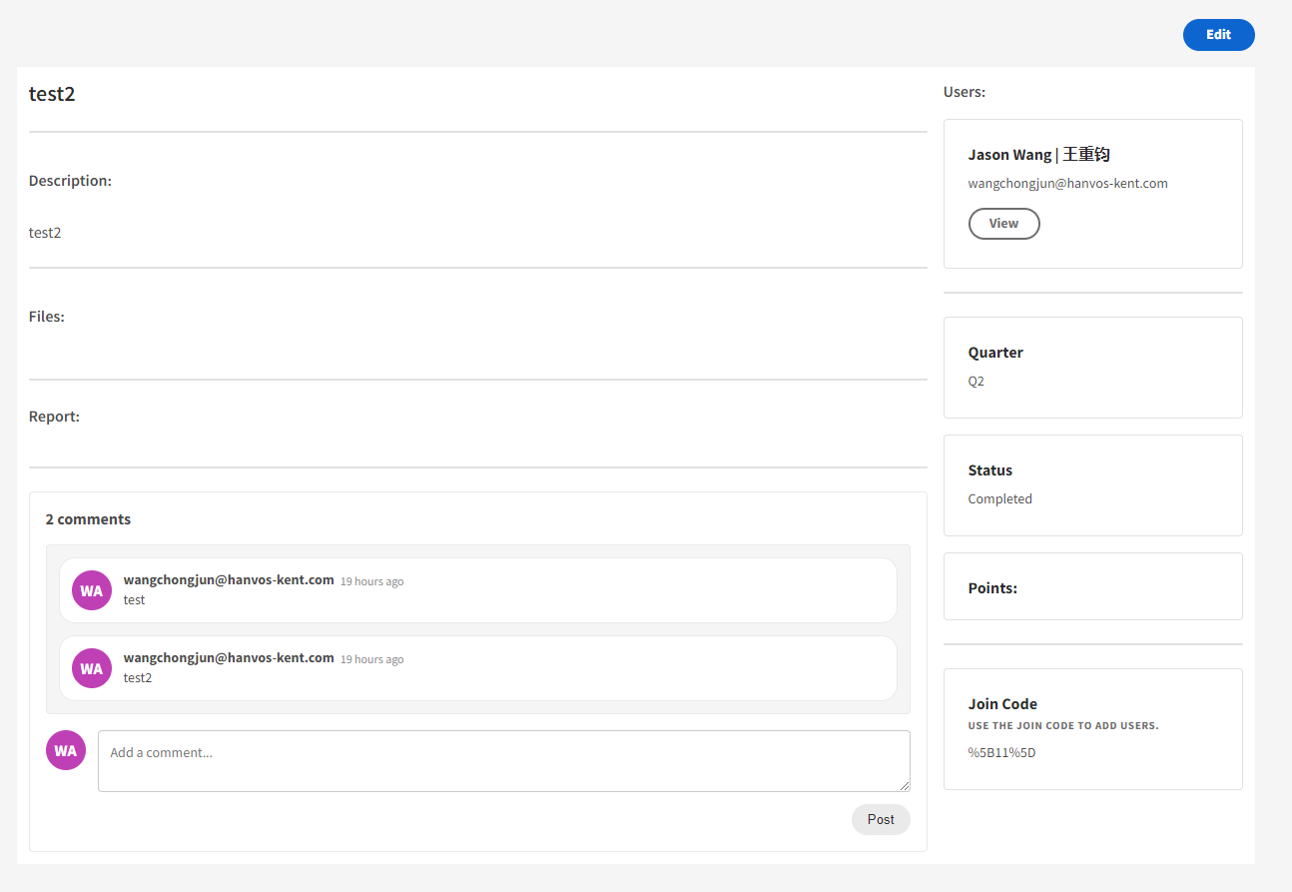

You can check on your proposal by clicking View. Here you will see a list of all of the information relating to the proposal. If you would like to add other users to the task, provide them with the join code on the right, and they can input it the join box of the My Project Proposal page.



You can also edit your project proposal info by clicking the edit button.

## Report

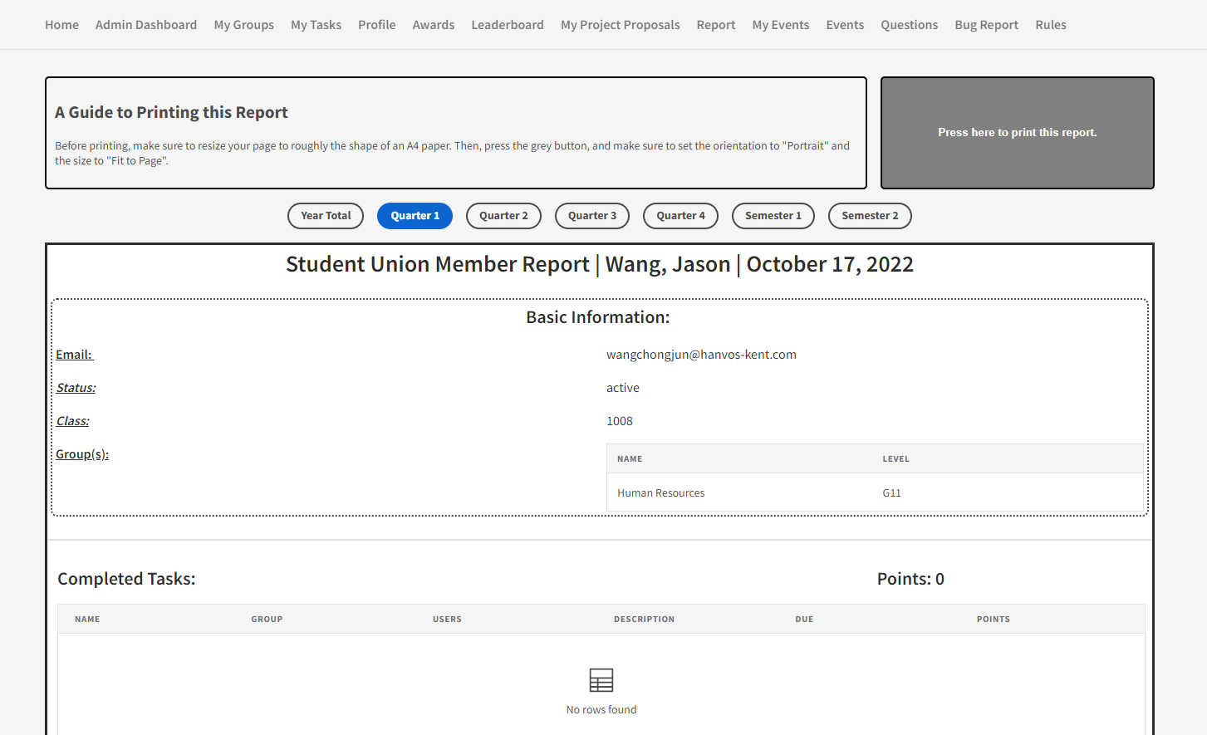

Here you can see a report of all the work you have done in the organization. You can filter this report by different time frames. To print the page, follow the instructions at the top of the page.

## My Events

For Access level: Power and Above

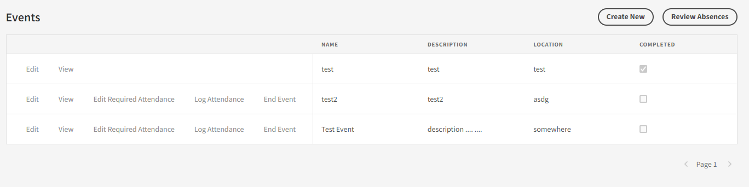

This section allows you to host events.

### Create New Event (Create new button)

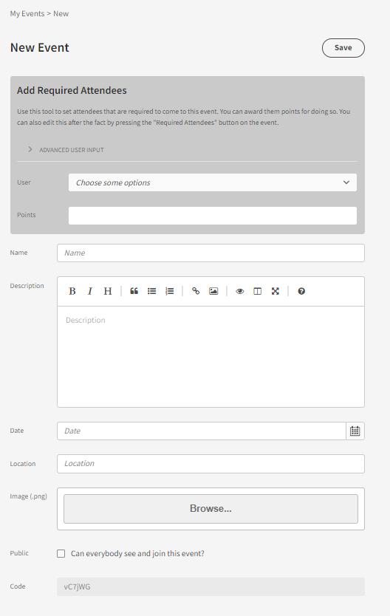

Here you can edit the settings for your event. Give it a name, date, description, location and even banner image. Select required attendee for your event (users who will be automatically signed up for the event and cannot cancel). Also make sure to select whether you want the event to be public or not. Public events are listed in the events section of everyone within the system, and they are free to sign up for the event on their own. Private events will only be visible to users who you add as required attendees to the event. Click save when you are done. Note that when users are added to an event, they will receive an email notification about it.

### Review absences (Review absense button)

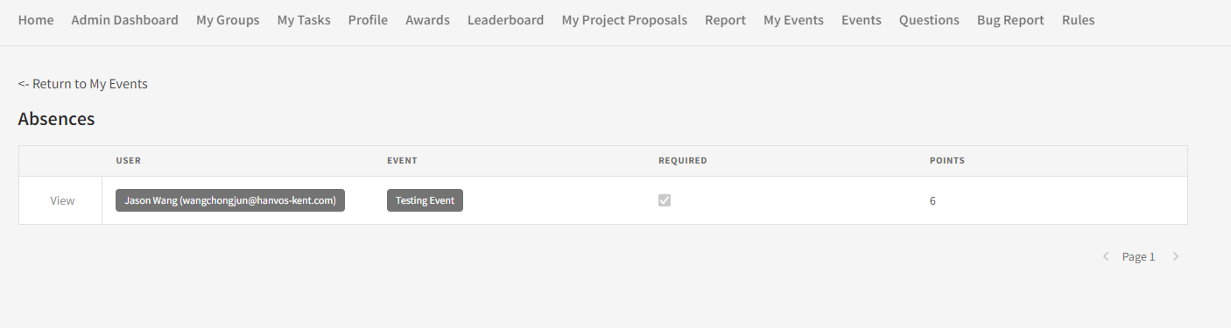

If you have members who are absent to any of your events, you can review them here. Users are able to submit an absence request to explain why they are absent.

### edit (Edit button)

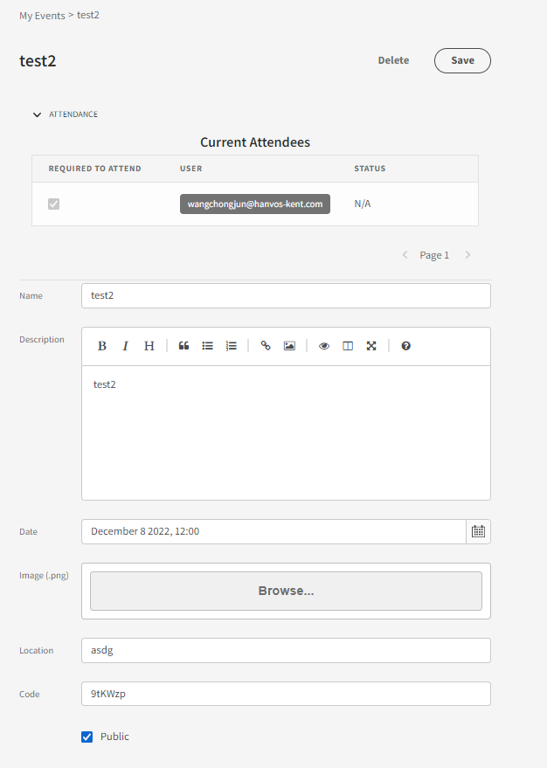

Here you can edit details about your event.

### View (View Button)

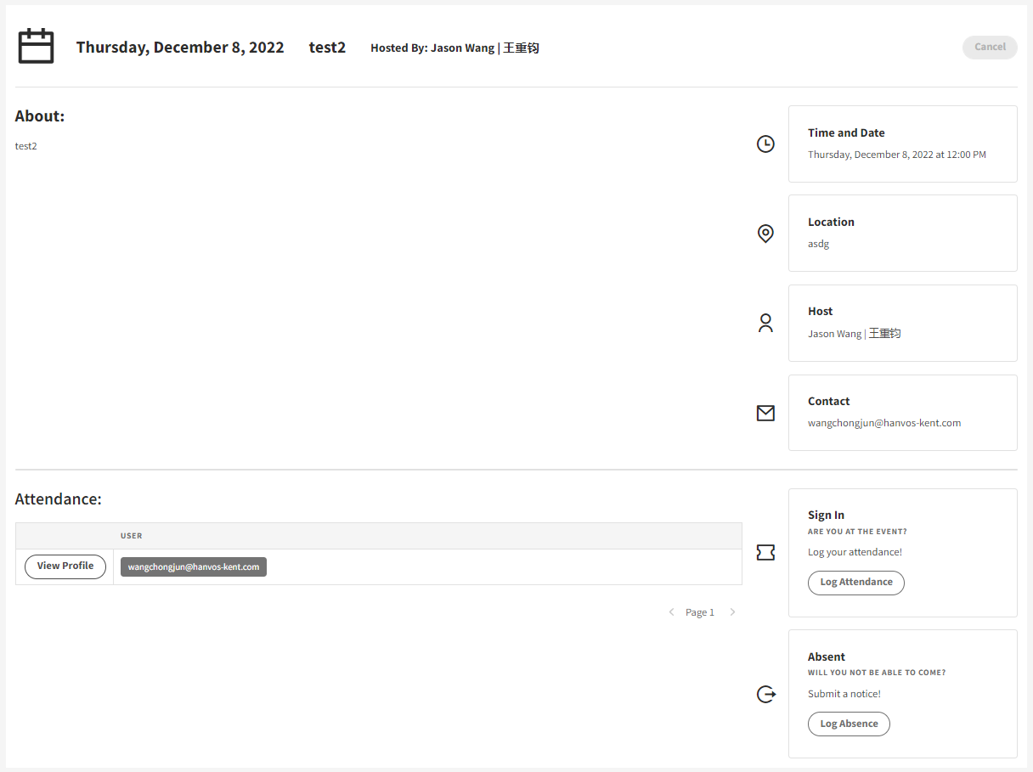

Here you can see the event page for your event. This is what is seen by attendees.

### Edit Required Attendance (Edit Required Attendance Button)

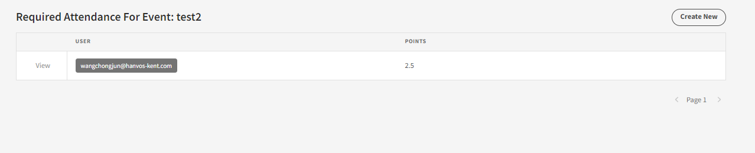

Here you can edit who is required to come to your event. Either add new people with “Create New” or remove people by clicking on an attendance with the “View” button and clicking delete on the info page.

### Log Attendance (Log Attendance Button)

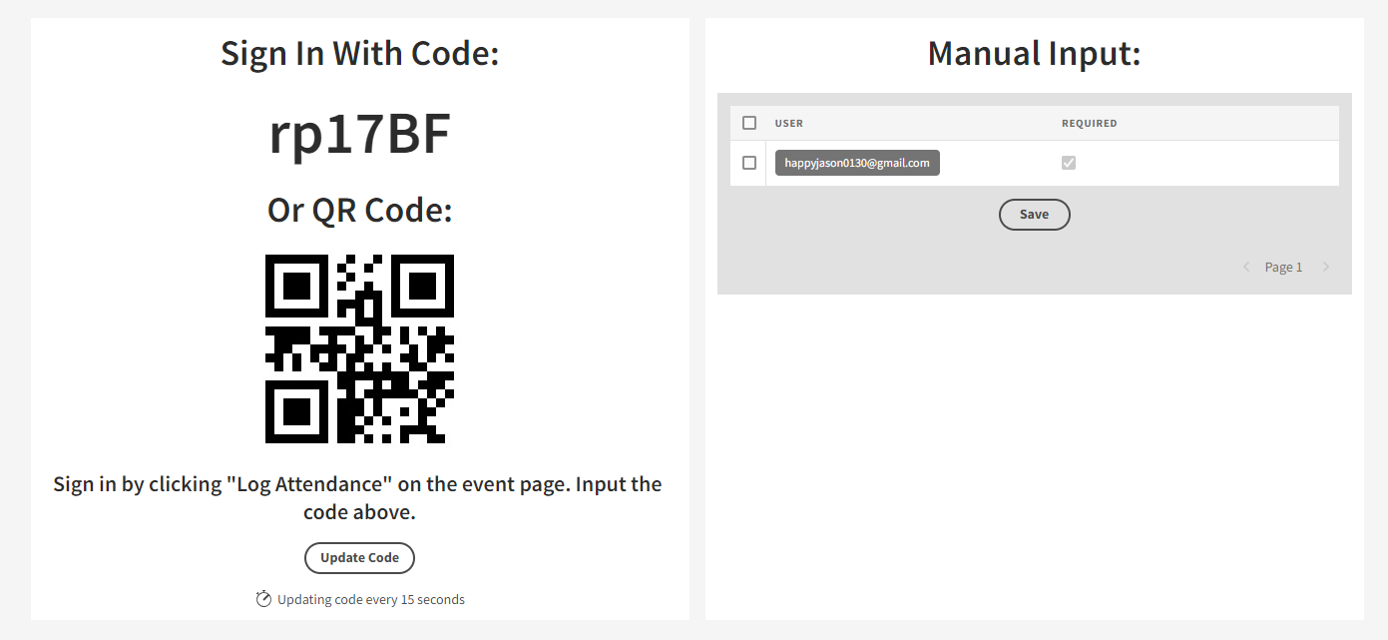

This is the page you show during your event to allow people to log their attendance.

### End Attendance

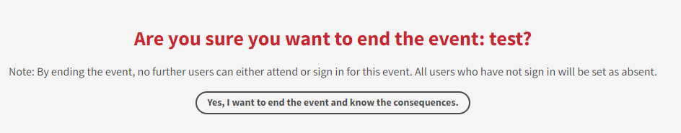

On this page, you can end your event. This has a couple of effects. Firstly, no further people can sign up or sign in for your event after you end it. Secondly, all users who have not signed in will be marked as absent.

## Events

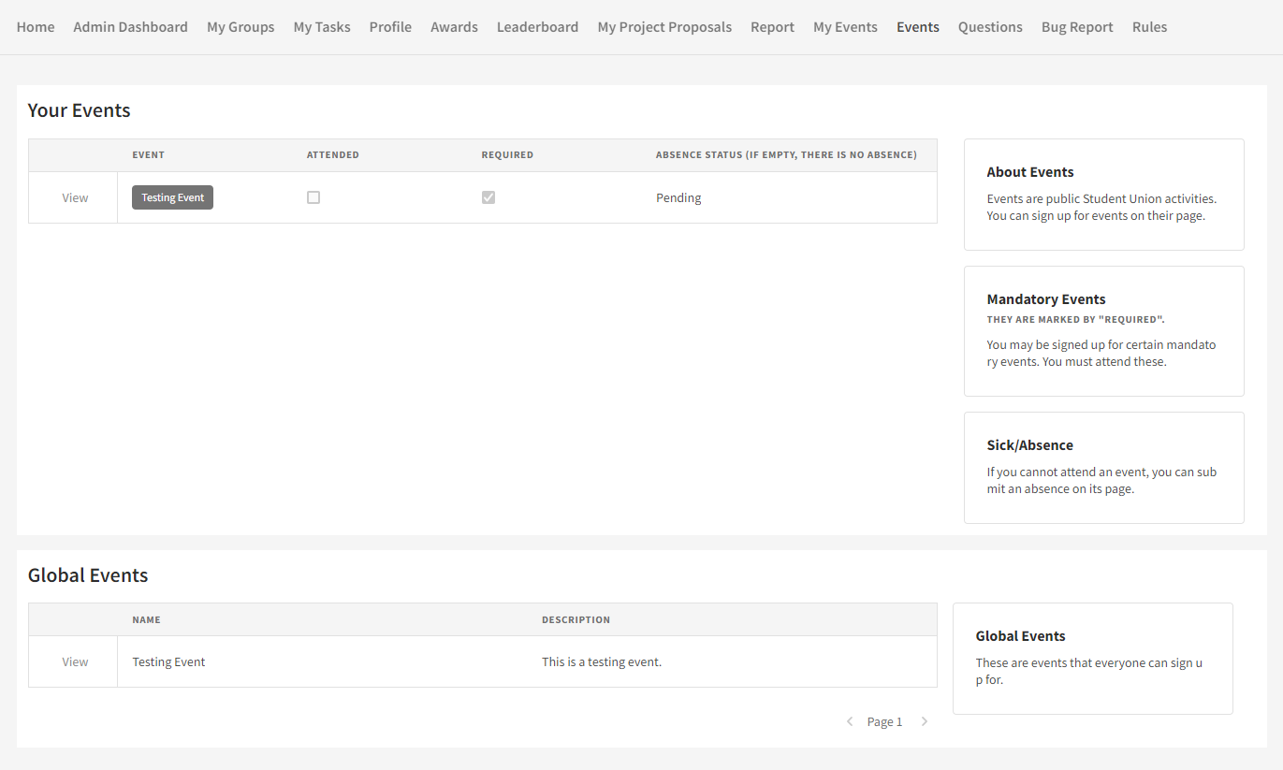

Under Your Events, you can see all of the events you have signed up for. If you are required to join an event, it will show up here. Global Events are events that are open to everybody. You are free to join these events.

### Event Page (View Button)

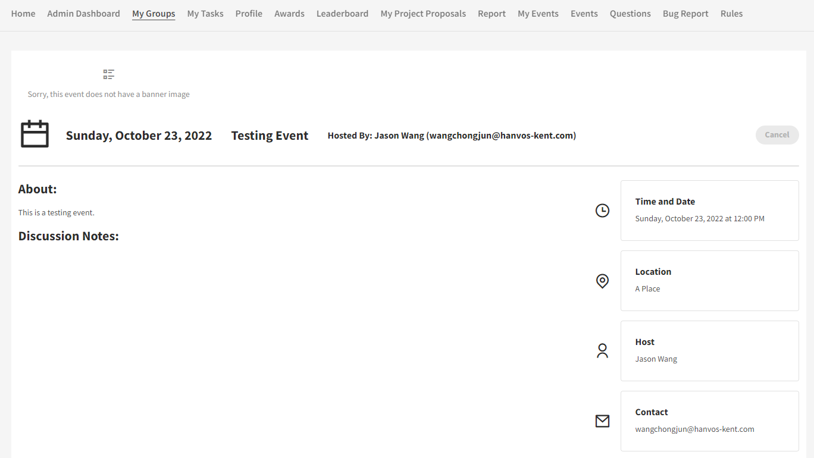

Each event has its own page. Here you can see all the important information about the event. You are also able to sign up for events on this page.

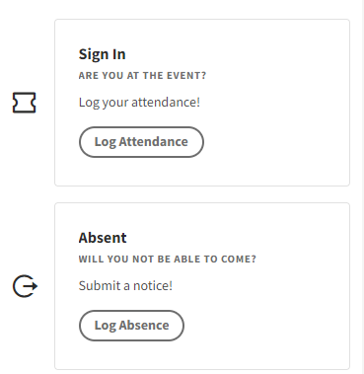

If you have signed up for an event, you will see a button to either sign in or to request an absence. To sign in, you will need to scan the QR code provided by the event organizer.

## Questions

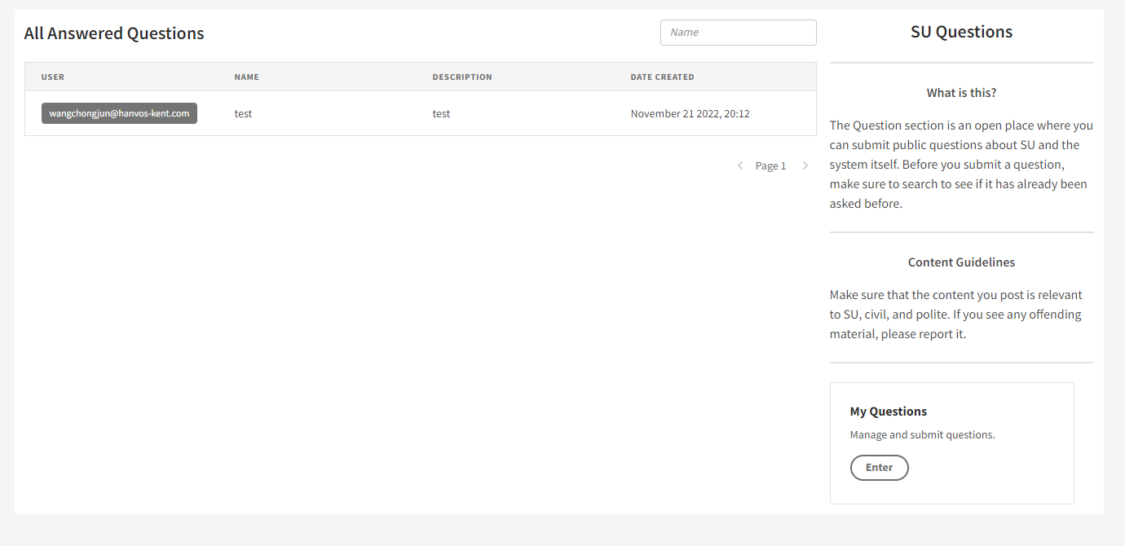

Here you view questions and answers about SU and the system. You can search the questions using the search bar at the top.  
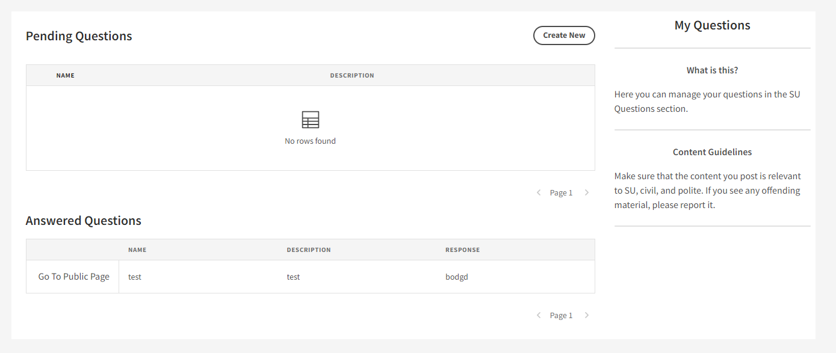

You can also ask your own questions by going the My Questions page. Note that all questions you ask are publicly viewable. Before you ask a question, make sure that it has not been asked already. Click Create New to ask a new question. Your questions that have not been responded to will be seen in the pending questions table. Responded questions will be displayed in answered questions table. Click on a question there to see the response.

## Files

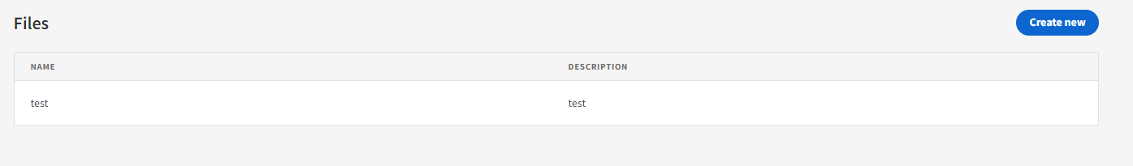

This is a system to upload and manage files. The purpose of this is to allow users to reference and share files in chatboxes. Users can upload files on this page, which will generate a unique file link for them to send as text. Any existing files you have uploaded will show up in the table. Click on them to either edit them or to copy their link. Click create new to upload new files.

Note: Do not use this for any non-SU related files. Furthermore, do not use this for large files such as videos. There is a file upload size limit.

## Bug Reports

Submit bug reports here! We would greatly appreciate if everyone submits a bug report if they encounter one. Please make sure that your submission is as descriptive as possible. Note that this is no longer part of the system and links to an external questionnaire site.

## Documents

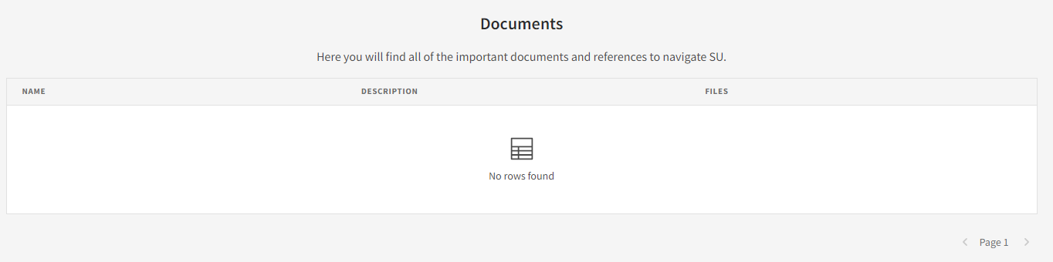

Here you will find files and important documents.

# Software Version Log

|  |  |
| --- | --- |
| Version: | Changes: |
| 1.0.0 (Demo) | Demonstrated functionality using Appsmith platform. |
| 1.0.1 (Rewrite) | Recreate system to allow for extendibility on Budibase.  Functionality:   1. Groups 2. Users 3. Tasks 4. Project Proposals 5. Report 6. Bug Report |
| 1.0.2 (Bug Fixes) | Fixed minor issues pertaining to all categories. |
| 1.1.0 (Big Features Update) | Added new functionality:   1. Admin Dashboard (which includes 7 subpages) 2. Profile Page 3. Awards 4. Leaderboard 5. My Events/Events 6. Questions 7. Rules |
| 1.1.1 (Bug Fixes) | Fixed minor issues pertaining to all categories. |
| 1.1.2 (Event Update) | Fixed bug issues pertaining to Events, and added new functionality:   1. Bug Fix: Resolved “Document Update Conflict” when reloading code in event attendance page. 2. Bug Fix: Resolved links in breadcrumbs pointing to undefined URLs. 3. Bug Fix: Resolved 4. Functionality: Added Review Absences page to allow event owners to review absences on their own events. 5. Functionality: Added QR Scanning as an option to verify attendance. 6. Functionality: Added Required Attendance page to allow event owners to set and delete required attendees an event. 7. Compatibility Breaking Changes: The URL paths of some of the event related pages has been changed. 8. Other minor changes. |
| 1.1.3 (Tasks Update) | Added new functionality:   1. Updated UI on view tasks to be more user friendly. 2. Added view button for those with edit permissions. Previously edit and view was either or. 3. Added a chat box to the bottom of the View page on a task. This will facilitate conversation about a task. |
| 2.0.0 | Major system rework, changing backend DB from CouchDB to MySQL and reworking a bunch of pages. Pages now load significantly faster.  Features:   1. Reworked all pages to support the new SQL backend. 2. Redesigned DB to be more efficient. 3. New SQL views and queries to reduce redundant information from slowing down load times. 4. Files are now stored in row in DB instead of being hosted on a separate MinIO server. (While this may not sustainable for large system, for an internal system with relatively low milage this maintains the SQL DB as the single source of truth for all the data). 5. Significant updates to the Events system and related pages.    1. Reworked to support the concept of an event ending, marking all unattended as absent.    2. Email notifications for new event attendees.    3. Cleaned up UI.    4. Various bug fixes.    5. Updated sign-in feature. QR code feature hidden for the moment due to http restrictions, and code now automatically updates itself every 15 seconds to curb non-attendees from signing in. Additionally, bugs regarding this feature were fixed. 6. Updates to user data and information.    1. User information is now stored in a SQL table and is related to the internal DB user list via email.    2. Views have been created that allow user ranks and statistics to be easily accessible. 7. Onboarding Experience    1. An all-new one-time setup onboarding experience that allows users to input essential user information. 8. File Upload    1. A system for users to upload files and receive a shareable link (usable only for system users). This enables files to be shared in comment conversations. 9. Questions:    1. Overhaul of UX and the setup of the Question page so that it is more useful. Instead of individual private questions it is now a forum, where questions about the student union and the system are viewable and searchable by all users. This saves admin time answering repeat questions. Additionally, there is a new question management section for users to keep up with the questions they have asked. 10. Project Proposal:     1. Adopts a comment system to replaces various tedious hardcoded phases of back and forth between admin and user.     2. New join code allows users to “share” a project proposal with others and allow them to join in. This replaces a trust-based system of allowing users to select partners from anyone within the system.     3. New status system – not all that important, just how the status is represented in the DB. 11. New Plugins:     1. Implemented 2 new open-source custom plugins, a [file uploader](https://github.com/chungchunwang/Budibase-File-Upload) and a [file repeater](https://github.com/chungchunwang/Budibase-File-Repeater). This has allowed for in-DB file storage, which was previously not possible in Budibase. 12. Miscellaneous:     1. Reworked the selection of Users on many pages. Previously the used of Advanced User Input allows users to inject selections from a more complicated user selection form. Such an injection is unintuitive, so it has been replaced, with the Advanced User Input form being the default on most pages.     2. Bug report is now in Microsoft Forms. Detaching it from the system makes it more accessible when it is most useful (when the system is down or has errors).     3. Rules has been renamed Documents.     4. Most tables and cards that include users now clearly link to their profile page.     5. Reworked the design of the task pages to be prettier.   Other minor details have been omitted for brevity. |
| 2.0.1 | Minor bug fixes, as well as enabling QR Code scanning for events, which will can only be used under https. |

# Known bugs and issues

* Event points are not added to the final point count. This is not a bug, and will be implemented soon.

# About the software & its design

The system is built atop the open-source low-code platform [Budibase](https://github.com/Budibase/budibase). Additionally, data is hosted on a MySQL instance.

## Why low code?

While I initially planned to build the system using React, Tailwind CSS, and other component libraries, I ended up opting for a low-code platform because this project is designed to be maintained into the future. Low-code platforms make maintenance easy and diminishes roadblocks to development.[2] The problem with a low-code platform, however, is its restrictions on functionality, due to the limitations of drag and drop as well as the relative newness of the software. I have tried to solve these issues by creating custom plugins and submitting bug reports to Budibase.

## Why MYSQL?

Most of the data for this system is highly relational, so using a SQL DB improves performance dramatically. The initial version of the system used the Budibase internal DB (which used CouchDB, see update 2.0.0) and the shift to MySQL improved performance dramatically.

## How is it hosted?

Everything is run through docker on an Ubuntu instance running in the cloud. There should be 2 docker images that just need to be loaded to setup a clean system. Instructions will be in the setup section below (currently non-existent). The idea is that a new Budibase app + MySQL schema is created for each year, with past years frozen in a read-only mode for reference purposes.

# System Setup

Work In Progress…

1. For example, don’t accidentally delete someone’s task!
2. As a side note, if anybody decides to rework the system with more substantial code in the future, I think NextJS might be a good idea. As the system is mostly data driven, if you use server-side rendering you won’t have all the hassle creating a bunch of API points for your app to query.